**Project 4: Maze**

**MAZE 15**

Jimmy Truong

Colorado School of Mines

CSCI 406: Algorithms

**Problem Modeling**

1. Modeling Explanation I modeled the graph by using the cells of the maze as vertexes and the possible moves are undirected edges. In the code I created an adjacency list using a Python dictionary with the keys as vertexes and a 2D list with the 0 index as the possible horizontal moves and 1 index with possible diagonal moves.

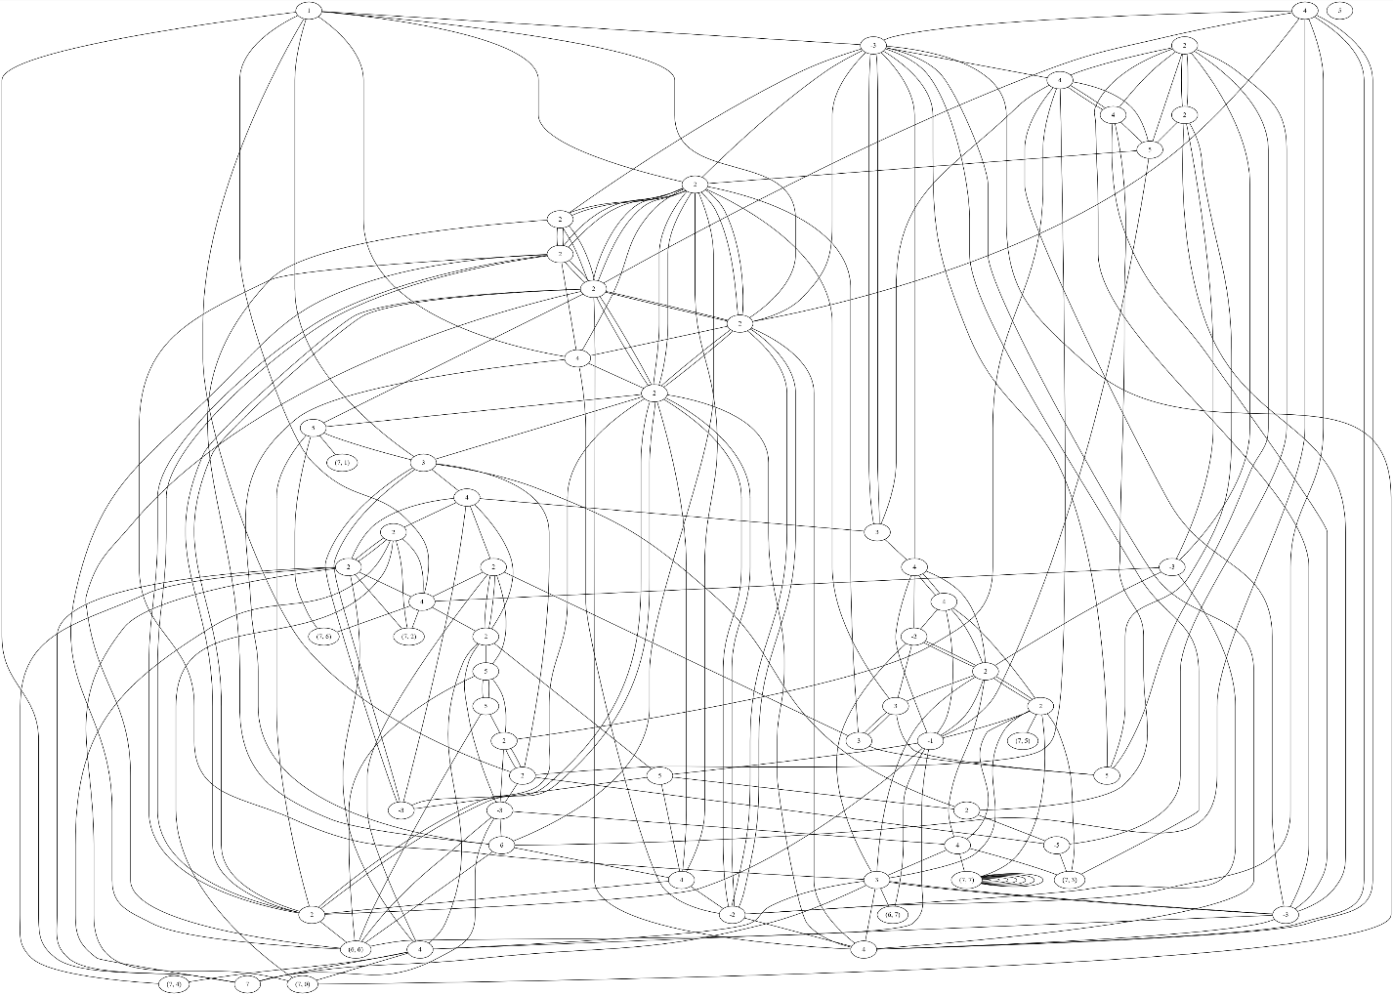

1. I used DFS to solve the problem.
2. This algorithm will actually solve this problem because I created an adjacency list of the whole graph. Afterwards, I created a dictionary that contains parents of nodes that get us there the fastest. I then pre-order traverse the dictionary to get the path.

**Code Submission**

from pprint import pprint

import graphviz

with(open("input.txt", "r")) as f:

    maze = [[int(num) for num in line.split(' ')] for line in f]

rows = maze[0][0]

cols = maze[0][1]

maze = maze[1:]

adj_list = {}

*# print(rows, cols)*

*# Create adjacency list for positive cells*

for i in range(rows):

    for j in range(cols):

        if (i, j) not in adj_list:

            adj_list[(i, j)] = [[], []]

        value = maze[i][j]

        value = abs(value)

*# North East*

        ne = (i - value, j + value)

*# South East*

        se = (i + value, j + value)

*# South West*

        sw = (i + value, j - value)

*# North West*

        nw = (i - value, j - value)

        if ne[0] >= 0 and ne[1] < cols:

            adj_list[(i, j)][1].append(ne)

        if se[0] < rows and se[1] < cols:

            adj_list[(i, j)][1].append(se)

        if sw[0] < rows and sw[1] >= 0:

            adj_list[(i, j)][1].append(sw)

        if nw[0] >= 0 and nw[1] >= 0:

            adj_list[(i, j)][1].append(nw)

        up = (i - value, j)

        down = (i + value, j)

        left = (i, j - value)

        right = (i, j + value)

        if up[0] >= 0:

            adj_list[(i, j)][0].append(up)

        if down[0] < rows:

            adj_list[(i, j)][0].append(down)

        if left[1] >= 0:

            adj_list[(i, j)][0].append(left)

        if right[1] < cols:

            adj_list[(i, j)][0].append(right)

*# pprint(adj_list)*

*# Set of negative points in the maze*

diagPoints = set()

for i in range(rows):

    for j in range(cols):

        if maze[i][j] < 0:

            diagPoints.add((i, j))

*# Depth First Search the adjacency list*

*# adj_list[(i, j)][0] = list of nodes that can be reached horizontally and vertically from (i, j)*

*# path = list of nodes that form the path from start to end*

*# https://www.geeksforgeeks.org/depth-first-search-or-dfs-for-a-graph/*

def DFSUtil(vertex, visited, diagonal=0, diagonal_visited=set(), parent=None, caller=None):

    if not diagonal:

        visited.add(vertex)

    else:

        diagonal_visited.add(vertex)

    if maze[vertex[0]][vertex[1]] < 0:

        if diagonal == 0:

            diagonal = 1

        else:

            diagonal = 0

    for v in adj_list[vertex][diagonal]:

        if diagonal == 1:

            if v not in diagonal_visited:

                if v not in parent:

                    parent[v] = {vertex}

                else:

                    parent[v].add(vertex)

                DFSUtil(v, visited, diagonal, diagonal_visited, parent,vertex)

        else:

            if v not in visited:

                if v not in parent:

                    parent[v] = {vertex}

                else:

                    parent[v].add(vertex)

                DFSUtil(v, visited, diagonal, diagonal_visited, parent,vertex)

def dfs(vertex):

    visited = set()

    diagonal_visited = set()

    parent = {}

    DFSUtil(vertex, visited, 0, diagonal_visited, parent)

*# pprint(parent)*

    curr = (7,7)

    path = [curr]

    diagonal = False

*# Trace back the path from end to start*

    while curr != (0,0) or (curr == (0, 0) and diagonal):

        if curr in parent:

            if curr in diagPoints:

                diagonal = not diagonal

            for p in parent[curr]:

                if not diagonal:

                    if curr in adj_list[p][0]:

                        path.append(p)

                        curr = p

                        break

                else:

                    if curr in adj_list[p][1]:

                        path.append(p)

                        curr = p

                        break

    path.reverse()

    return path

mypath = dfs((0, 0))

*# reverse each element in the list and add 1*

for x in mypath:

    x = (x[1] + 1, x[0] + 1)

    print(x, end=" ")

*# Creates a graphical representation of the maze using graphviz*

dot = graphviz.Digraph(comment='Maze')

for i in adj_list:

    dot.node(str(i), str(maze[i[0]][i[1]]))

    for j in adj_list[i][0]:

        dot.edge(str(i), str(j), dir='none')

    for j in adj_list[i][1]:

        dot.edge(str(i), str(j), dir='none')

*# print(dot.source)*

**Results**

(1, 1) (1, 5) (4, 8) (8, 4) (5, 1) (1, 5) (1, 2) (4, 2) (4, 6) (8, 6) (7, 7) (1, 1) (5, 5) (7, 3) (2, 8) (4, 8) (8, 8)